Department of Electrical Engineering
Faculty Member: Dr Hassan khaliq | Dated: 4/7/2023
Semester: 6th | Section: BEE-12C
EE-357 Computer and Communication Networks
Experiment – 7
Introduction to Dynamic Routing
 |  | CLO5-PLO9
Name | Reg. No | Individual and Teamwork  5 Marks | Lab Report  10 Marks | Quiz/viva  5 Marks
Muhammad Ahmed Mohsin | 333060
Amina Bashir | 343489
Imran Haider | 332569

- Table of Contents
2 1. Objective 3
3 2. Resources Required 3
4 3. Introduction 3
5 3.1 Types of Routing Protocols 3
6 Types of Interior Gateway Routing Protocols 3
7 3.3 Administrative Distance & Metric 4
7.1 Remember: 4
8 Lab Tasks: 5
8.1 Lab Task 1: 5
8.2 ScreenShot: 5
8.3 PC9 to PC2: 6
8.4 PC0 to PC 7: 6
8.5 PC0 to PC8: 7
8.6 Simulation shoing correct transfer of packet from PC8 to PC0: 7
8.7 Real time simultion showing correct trasnfer of packet from PC8 PC11 8
9 Lab Task 2: 8
9.1 Screenshot of the Network: 9
9.2 Screenshot of pinging PC 35 to PC 0 9
9.3 Pinging PC 3 by PC 31: 10
9.4 Pinginf pc 33 from pc 6 10
9.5 Real time simulation of message travelling from pc 35 to pc0 11
10 Conclusion: 11

EXPERIMENT NO 7
Introduction to Dynamic Routing (RIP)

1. Objective
This lab exercise is designed to understand routing and procedure to setup RIP on routers

2. Resources Required
- Computer
- Packet Tracer (version 5 or higher)

3. Introduction
A routing protocol is a protocol that specifies how routers communicate with each other, disseminating information that enables them to select routes between any two nodes on a computer network, the choice of the route being done by routing algorithms. Each router has a priori knowledge only of networks attached to it directly. A routing protocol shares this information first among immediate neighbours, and then throughout the network. This way, routers gain knowledge of the topology of the network.

3.1 Types of Routing Protocols
There are two main types of routing protocols:
- Interior Gateway Protocol (IGP) is a routing protocol that is used to exchange routing information within an autonomous system (AS). Examples are RIP, OSPF
- Exterior Gateway Protocol (EGP) is for determining network reachability between autonomous systems (AS) and makes use of IGPs to resolve routes within an AS. Examples are BGP & EGP.

Types of Interior Gateway Routing Protocols
IGPs can be divided into following three types:
- Distance vector: The distance-vector protocols find the best path to a remote network by judging distance. Each time a packet goes through a router, that is called a hop. The route with the least number of hops to the network is determined to be the best route. The vector indicates the direction to the remote network. Both RIP and IGRP are distance-vector routing protocols. They send the entire routing table to directly connected neighbours.
- Link state: In link-state protocols, also called shortest-path-first protocols, the routers each create three separate tables. One of these tables keeps track of directly attached neighbours, one determines the topology of the entire internetwork, and one is used as the routing table. Link state routers know more about the internetwork than any distance-vector routing protocol. OSPF is an IP routing protocol that is completely link state. Link state protocols send updates containing the state of their own links to all other routers on the network.
- Hybrid: Hybrid protocols use aspects of both distance vector and link state—for example, EIGRP.

There is no set way of configuring routing protocols for use with every business. This is something you really have to do on a case-by-case basis. If you understand how the different routing protocols work, you can make good, solid decisions that truly meet the individual needs of any business.

3.3 Administrative Distance & Metric
Metric is a property of a route in computer networking, consisting of any value used by routing algorithms to determine whether one route should perform better than another. It is used to choose the best route among the routes found by same routing protocol.

Administrative distance is the measure used by Cisco routers to select the best path when there are two or more different routes to the same destination from two different routing protocols. Administrative distance defines the reliability of a routing protocol. Each routing protocol is prioritized in order of most reliable to least reliable (believable) using an administrative distance value.

Remember:
- A smaller value (Metric or Administrative distance) means a better route
- Administrative distance has more preference over Metric.

Lab Tasks:

Lab Task 1:
Create the following topology and use dynamic IP routing to connect the routers. Provide screenshots showcasing your work including the Packet Tracer window, CLI window (particularly the Router RIP portion) and ping screenshots. In the ping screenshots, you must show successful ping from multiple networks in the same CMD window.
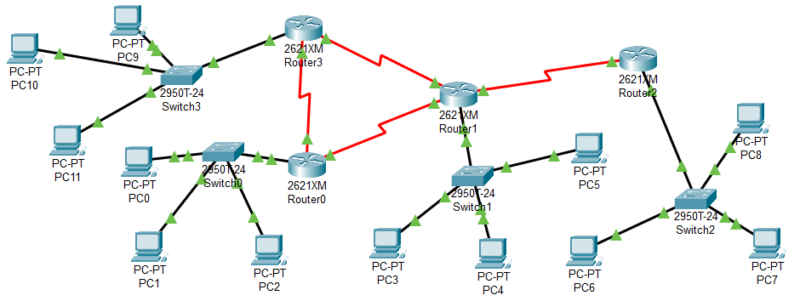

ScreenShot:
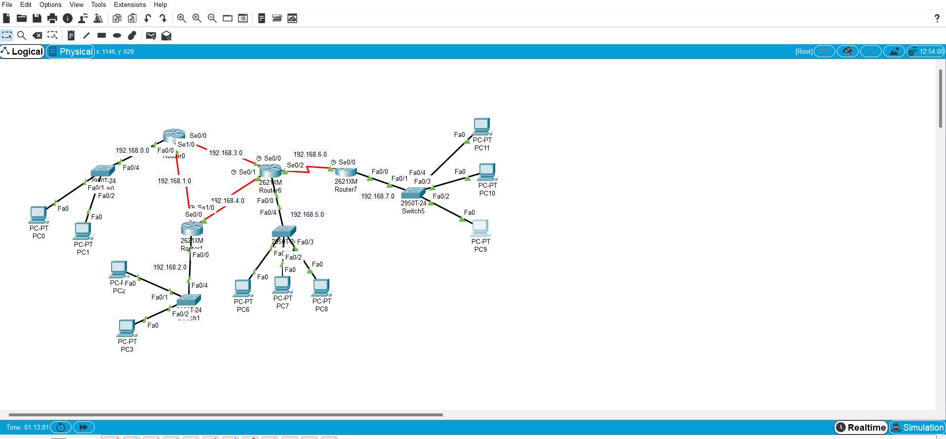

PC9 to PC2:
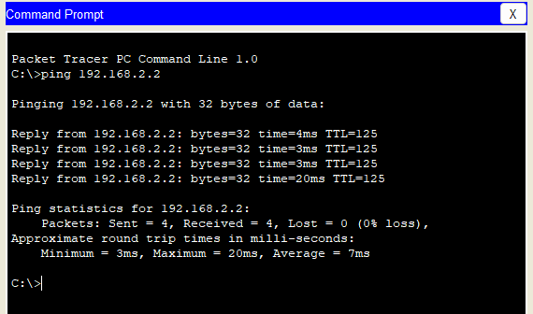

PC0 to PC 7:
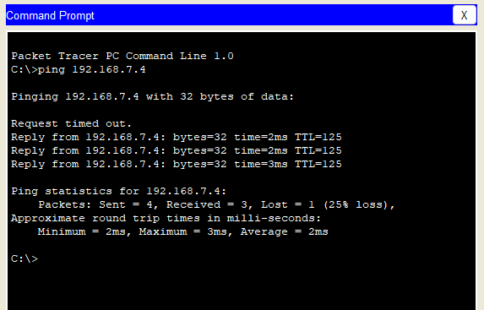

PC0 to PC8:
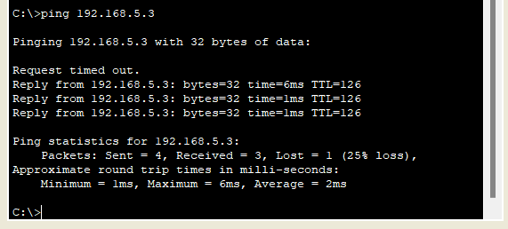

Simulation shoing correct transfer of packet from PC8 to PC0:
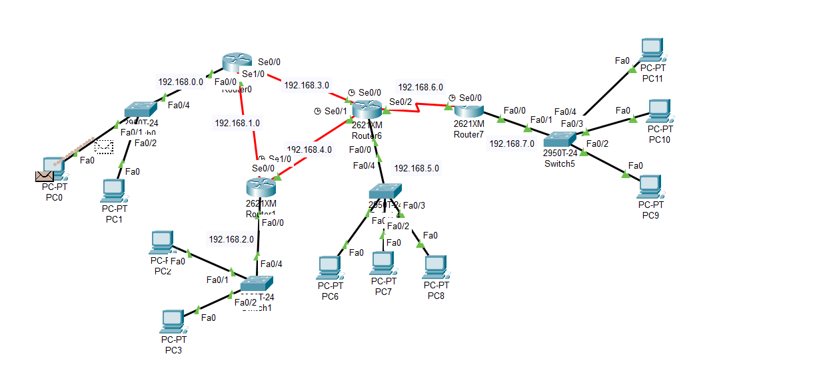

Real time simultion showing correct trasnfer of packet from PC8 PC11: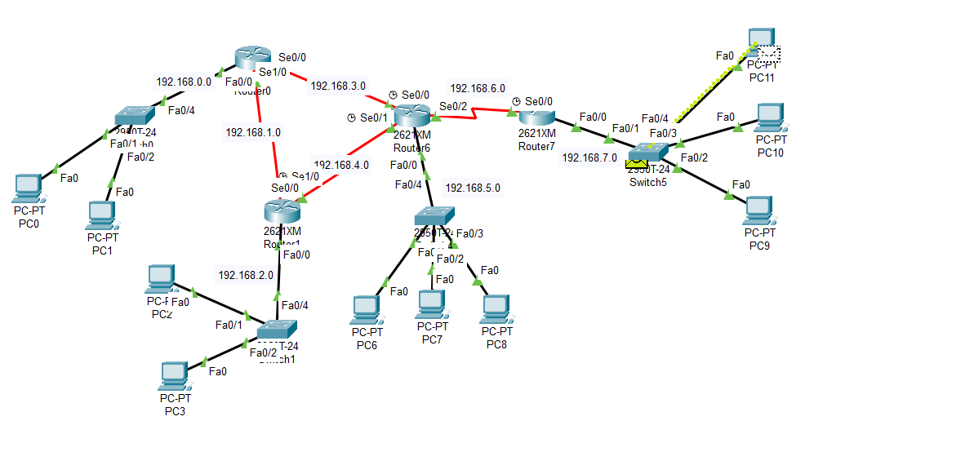

Lab Task 2:
Using the concepts that you have learnt in this lab, build a topology consisting of at least 10 routers and a total of 50 PCs. The design of the topology is entirely up to you. Provide screenshots showcasing your work. You will also need to submit the packet tracer file (.pkt) for this task.

Screenshot of the Network:
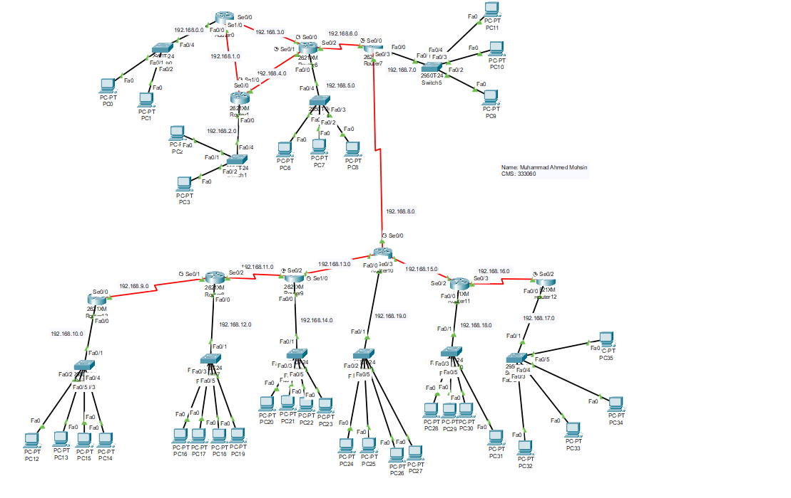

Screenshot of pinging PC 35 to PC 0
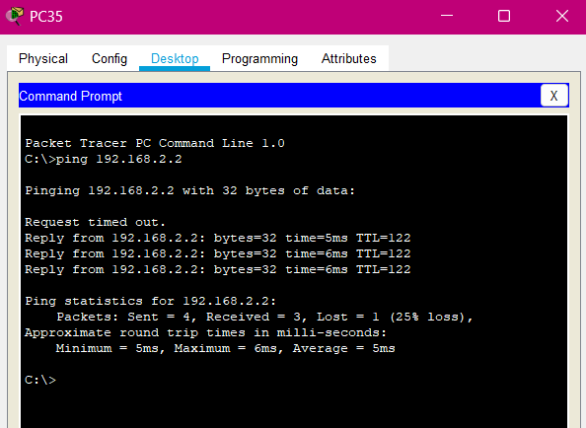

Pinging PC 3 by PC 31:
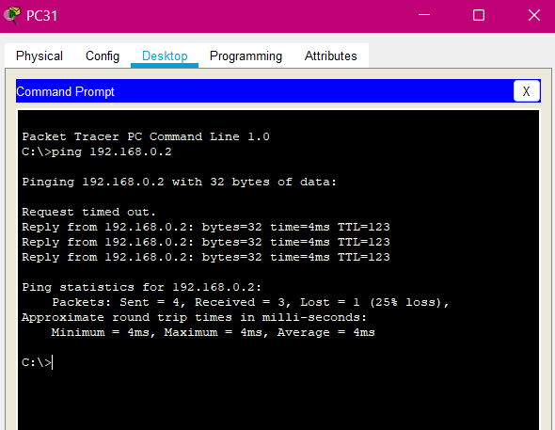

Pinginf pc 33 from pc 6
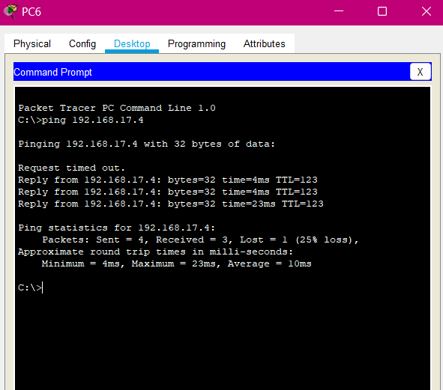

Real time simulation of message travelling from pc 35 to pc0
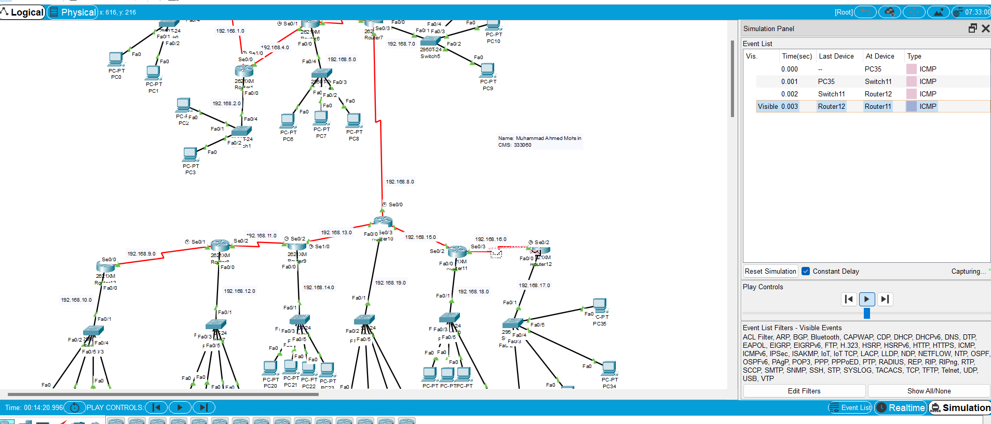

Conclusion:
In conclusion, our lab experiment using CISCO packet tracer demonstrated the effectiveness of dynamic routing protocols in efficiently managing network traffic. The use of dynamic routing protocols allowed for the automatic updating of routing tables, improving network performance and reducing the need for manual intervention. This exercise has provided us with valuable insights into the workings of dynamic routing and its potential applications in real-world network environments. Overall, the successful completion of this lab has enhanced our understanding of networking fundamentals and the importance of effective routing protocols in maintaining a stable and efficient network.

